STATEMENT OF WORK
School Management SaaS Platform
Admin Panel | Teacher Panel | Parent Panel | Web UI | Mobile Application

Document Field | Value
Version | 1.0
Purpose | Client review, scope agreement, and delivery baseline
Solution Scope | Multi-tenant school SaaS with web and mobile channels
Primary Users | School Admin, Teachers, Parents / Guardians
Prepared For | School Client

1. Executive Summary
This Statement of Work defines the scope for a multi-school, multi-tenant School Management SaaS platform. The solution will provide role-based access through separate Admin, Teacher, and Parent experiences across web and mobile channels. The platform will cover admissions, student profiles, academic operations, fee and ledger management, notifications, reports, parent communication, and configuration management. The design is intended for a mid-level product that can be launched for one school and scaled into a broader SaaS offering without redesigning the core platform.

2. Project Objectives
- Digitize end-to-end school operations in a single configurable SaaS platform.
- Provide secure and separate panels for Admin, Teachers, and Parents.
- Automate fee posting, due calculation, payment recording, and receipt generation.
- Support academic workflows such as attendance, homework, marks, remarks, and report cards.
- Enable multi-channel communication through SMS, WhatsApp, email, and push notifications.
- Provide a scalable tenant-aware foundation for onboarding multiple schools.

3. Scope Summary
In Scope | Out of Scope (unless added later)
Web UI, mobile apps, admin workflows, teacher workflows, parent portal, fee ledger, notifications, reports, and multi-school configuration. | Native desktop app, biometric device integration, GPS bus tracking, online proctoring, accounting ERP replacement, and custom payment gateway certification.

4. Proposed Solution Overview
- Multi-tenant design where each school operates under a logically separated tenant.
- Centralized authentication with tenant resolution at login or subdomain level.
- Role-based authorization for Admin, Teacher, and Parent users.
- Configurable branding, fee structures, academic calendars, and notification templates per tenant.
- Auditability for all financial, academic, and communication-related actions.

Figure 1. Solution Architecture
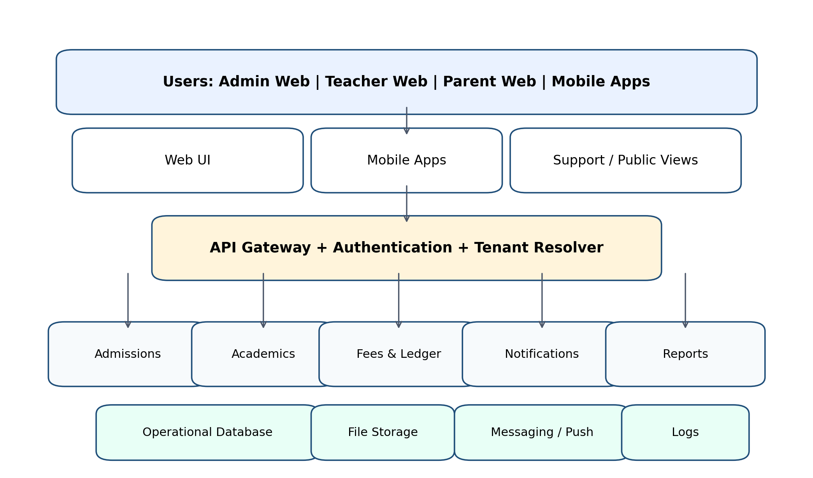

5. Channels and User Experience Scope
Channel | Audience | Key Scope
Web Admin Portal | School management and office staff | Admissions, master data, fees, reports, logs, configuration
Web Teacher Portal | Teachers and coordinators | Attendance, homework, marks, notices, class communication
Web Parent Portal | Parents / guardians | Fees, attendance, results, notices, downloads, messages
Mobile App | Parents and teachers | Push notifications, quick views, attendance, homework, payments, and reminders

6. Detailed Module Scope

6.1 Admin Panel
- Dashboard with school-level summaries for admissions, attendance, fee dues, collections, notifications, and pending actions.
- Admission management: enquiry capture, application, verification, approval, document upload, student ID generation, class/section assignment, sibling mapping, and student profile creation.
- Academic setup: academic year, classes, sections, subject mapping, house grouping, timetable setup, class teacher assignment, promotion, and rollover.
- Student master profile: demographic details, parent / guardian details, address, transport route, medical notes, documents, and academic history.
- Fee engine: fee structure setup, fee heads, installment plans, concession, scholarship, late fee, one-time charges, recurring charges, transport / hostel / exam / activity charges, and manual adjustments.
- Ledger engine: debit and credit entries, running balance, arrears, overpayment, refund handling, and transaction reference history.
- Expense posting: books, uniform, transport, fine, activity, lab, hostel, and other school-approved charges.
- Receipts and reconciliation: payment posting, receipt number generation, payment mode capture, cancellation / bounce handling, and settlement notes.
- Notifications: template management, event triggers, delivery logs, failure tracking, and multi-channel routing.
- Reports: student-wise due, class-wise collection, fee defaulter list, collection ageing, expense report, admission report, attendance report, and audit report.
- Tenant management: school onboarding, branding, plan assignment, configuration settings, and tenant-level access control.
- System settings: roles, permissions, holidays, grading rules, document types, payment modes, and communication settings.

6.2 Teacher Panel
- Teacher dashboard with assigned classes, subjects, upcoming tasks, attendance status, and announcements.
- Attendance management for daily class attendance, late, absent, leave, and remarks.
- Homework and assignment publishing with due dates, files, instructions, and class targeting.
- Assessment and marks entry with internal test scores, term exams, grade calculation, and remarks.
- Class communication for notices, parent messages, and teacher notes where permitted by school policy.
- Student view limited to academic and behavioral details for assigned classes.
- Timetable and schedule visibility across assigned periods and classes.
- Mobile-first quick actions for attendance, notice viewing, homework updates, and push notifications.

6.3 Parent Panel
- Parent dashboard with child summary, fee due status, attendance snapshot, recent notices, homework alerts, and results.
- Student profile view for academic history, attendance, report cards, notices, and downloadable documents.
- Fee and ledger view with current due, paid amount, balance carried forward, and receipt history.
- Payment visibility for online and offline payments, confirmation, and pending settlement updates.
- Notification center with SMS, WhatsApp, email, and push messages.
- Acknowledgement and response actions for selected notices where enabled by the school.
- Multiple children under one parent account with clear switching between students.
- Mobile app experience optimized for quick access, reminders, and push-driven updates.

6.4 Mobile Application Scope
- Android and iOS mobile app strategy, with feature parity on critical parent and teacher journeys.
- Parent mobile app: fee reminders, payment updates, attendance, report cards, notices, homework, and profile access.
- Teacher mobile app: attendance marking, homework updates, notice access, and quick alerts.
- Push notification support with template-based deep links into the relevant screen.
- Offline-tolerant capture for selected teacher actions if required by the school; sync on reconnect.
- Secure session handling, device logout, and basic app-level access controls.

6.5 Web UI Scope
- Responsive browser-based UI for desktop and tablet usage.
- Bulk operations for admissions, fee setup, data import, and report extraction.
- Administrative back-office controls and detailed reporting screens.
- Search, filters, pagination, and export for operational usability.

7. End-to-End Workflows
Workflow | Trigger / Action | System Outcome
Admission | Admin captures student details, uploads documents, assigns class and section. | Student profile created, admission number generated, ledger initialized, fee plan assigned.
Fee Posting | Fee or expense is posted to a student account. | Debit entry added, dues recalculated, parent notified if balance is due.
Payment Receipt | Parent pays through cash, bank, cheque, or online mode. | Credit entry recorded, receipt generated, balance updated, confirmation sent.
Notification | Fee due date, payment event, or reminder threshold is reached. | Template selected, channel used, delivery logged, retry path tracked.
Attendance | Teacher marks daily attendance for class. | Attendance summary updated and parent visibility updated where configured.
Assessment | Teacher enters marks or remarks. | Results become available to authorized users, report cards can be generated.
Figure 2. Fee and Ledger Flow
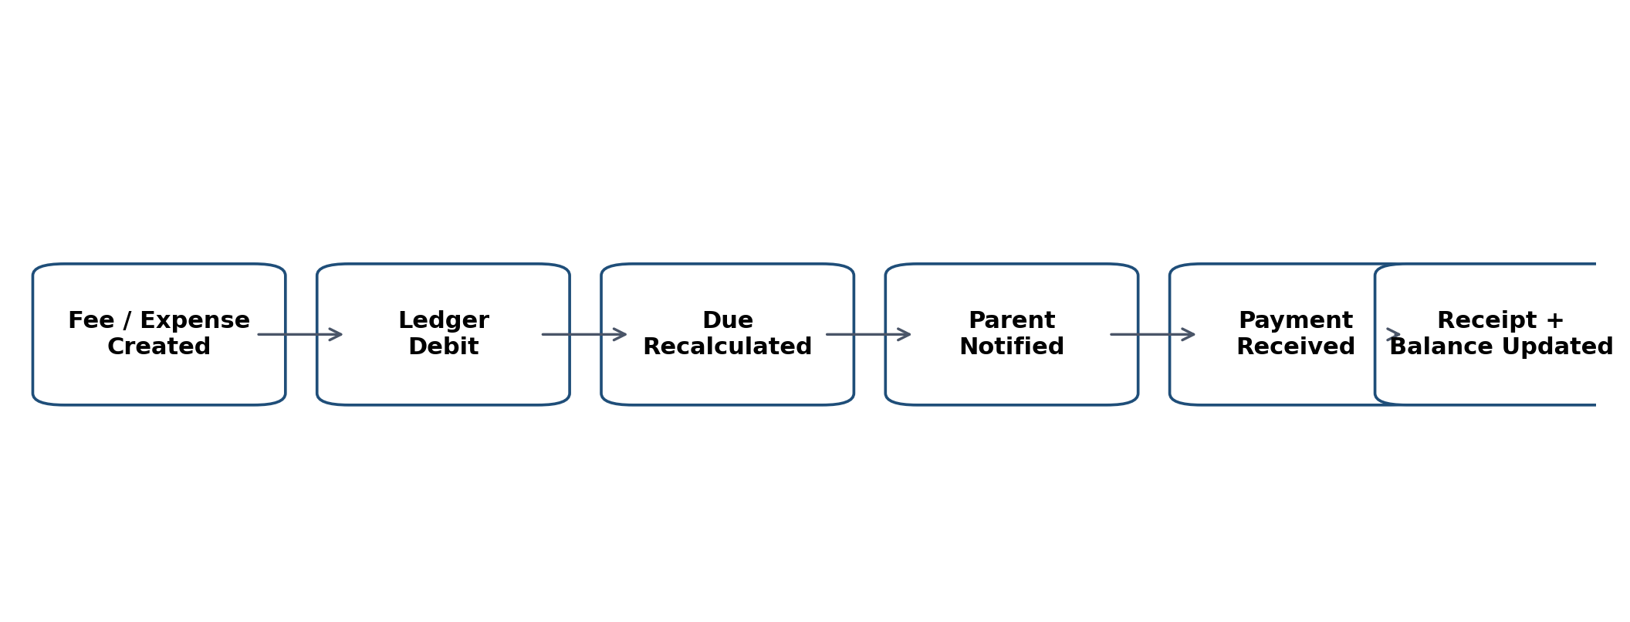
Figure 3. Notification Flow
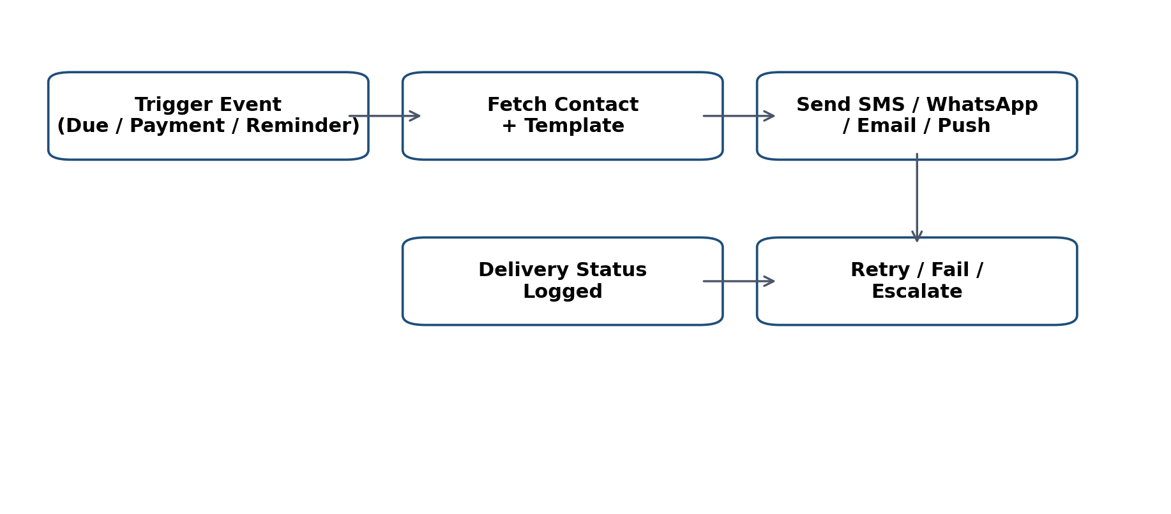

8. Fee, Ledger, and Accounting Rules
- Ledger balance should be calculated as Opening Balance + Total Debits - Total Credits.
- Debits include tuition, transport, hostel, exam fees, books, uniform, fines, activity charges, and approved adjustments.
- Credits include payments, concessions, scholarships, waivers, refunds, and reconciliation entries.
- The system must support partial payments, advance payments, overpayments, refunds, and bounced transactions.
- Every ledger movement must retain date, amount, mode, reference, user, and remarks for auditability.
- Due reminders must be configurable by due date, threshold, overdue days, or notification schedule.
- Each financial transaction should be visible in the student profile history.

9. Integrations and External Services
Integration | Purpose | Notes
SMS Gateway | Fee reminders and alerts | Delivery logs and retry handling required
WhatsApp Provider | High-engagement notifications | Template approval and opt-in rules may apply
Email Service | Receipts, notices, and reports | Domain and sender configuration needed
Payment Gateway | Online fee collection | Reconciliation and webhook handling required
Push Notifications | Mobile app updates | Topic / segment routing by tenant and role
File Storage | Documents and receipts | Secure access and retention policy required

10. Non-Functional Requirements
- Security: role-based access control, secure password policy, encryption in transit, audit logs, and tenant separation.
- Performance: responsive dashboards, paginated lists, and optimized fee / report queries.
- Availability: backup strategy, restore process, and operational monitoring.
- Scalability: tenant-aware architecture that can onboard additional schools without code redesign.
- Usability: intuitive workflows for non-technical staff and mobile-first parent usage.
- Maintainability: modular service design, configuration-driven fee and notification rules, and clear release process.

11. Core Data Entities
Entity | Description
School / Tenant | Tenant-level school configuration and branding
User / Role | Login account, permissions, and panel access
Student | Academic and personal profile
Parent / Guardian | Primary contact and notification recipient
Teacher | Staff profile, subject assignment, and class mapping
Fee Structure | Fee heads, plans, concessions, and recurring rules
Ledger Entry | Debit / credit transaction with running balance
Attendance Record | Daily attendance and summaries
Homework / Assessment | Assignments, submissions, marks, and remarks
Notification Log | Delivery status and communication trail

12. Deliverables
- Approved requirements baseline and final SOW.
- UI wireframes and responsive web design specification.
- Multi-tenant solution architecture and database design.
- Admin, Teacher, and Parent web portals.
- Parent and Teacher mobile applications.
- Notification templates and integration setup.
- Reports and export functionality.
- Testing support, UAT support, and deployment support.
- User guides for school staff and parents.

13. Indicative Delivery Plan
Phase | Estimated Duration | Outputs
Discovery & Finalization | 1-2 weeks | Confirmed scope, workflows, success criteria
UX / Architecture Design | 2 weeks | Wireframes, system architecture, data model
Core Development | 5-7 weeks | Panels, APIs, fee engine, attendance, notifications
QA / UAT | 2 weeks | Testing, defect closure, client sign-off
Deployment & Training | 1 week | Production release, training, handover

14. Commercial Placeholder
- Pricing model: SaaS subscription, per-school license, or per-student plan to be finalized.
- Implementation cost: To be filled after final scope sign-off.
- Recurring cost: Hosting, SMS, WhatsApp, email, and payment gateway charges to be defined.
- Support / AMC: To be defined based on SLA and support hours.

15. Assumptions and Dependencies
- School will provide policies for fee heads, academic structure, grading rules, and notification approvals.
- The client will provide SMS / WhatsApp / email / payment gateway credentials if these services are required.
- School-specific branding assets and legal text will be supplied by the client.
- Any future changes in scope will be handled through change control.

16. Acceptance Criteria
- All three panels are accessible with correct role-based permissions.
- Fee, ledger, and payment transactions calculate balances accurately.
- Notifications are generated and logged based on configured rules.
- Reports export correctly and reflect current data.
- Mobile and web journeys function for the defined user scenarios.
- UAT issues are closed and client sign-off is obtained.

17. Change Control
Any scope addition, integration request, or workflow change after sign-off will be documented separately as a change request with impact on timeline, cost, and delivery dependencies before implementation.

